Salesforce

This article describes how to connect Tableau to Salesforce.com data and set up a data source.

In this article

Before you connect

Make the connection and set up the data source

Use Dashboard Starters

Use joins in Salesforce

Troubleshoot Salesforce connections

Before you connect

Before you begin, gather this connection information:

* Salesforce user name and password

Use this connector with Tableau Desktop on a Windows computer.

Make the connection and set up the data source

1. Start Tableau and under Connect, select **Salesforce**. For a complete list of data connections, select **More**under **To a Server**. Then do the following:
   1. Enter your user name and password for Salesforce.com.
   2. Select **Log In**.
   3. In the Allow Access dialog box, select **Allow**.

If the connection is unsuccessful, verify that the authentication information is correct. If the connection continues to fail, your computer is having trouble locating the server or you may not have permission to access the data. Contact your network administrator or Salesforce administrator.

1. On the data source page, do the following:
   1. (Optional) Select the default data source name at the top of the page, and then enter a unique data source name for use in Tableau. For example, use a data source naming convention that helps other users of the data source figure out which data source to connect to.
   2. Select a standard connection or create your own custom connection.

Under **Standard Connection**, you can select from a list of predefined queries, which represent commonly used objects, and drag it to the canvas. Or, under **Table**, you can select a single table, which includes any custom objects your company has created, and drag it to the canvas.

* 1. Select the sheet tab to start your analysis.

Refresh Salesforce data

After you click the sheet tab, Tableau imports the data by creating an extract. Tableau Desktop supports only extracts for Salesforce.

**Note:** The initial extract may take some time depending on the amount of data that is included.

After the initial extract, you can do a full or incremental refresh of the extract. Incremental refreshes for Salesforce data include any Salesforce object that has been added or changed since the last incremental refresh. Results returned are limited to the previous 30 days.

To refresh, select **Data**> [data source name] > **Extract**> **Refresh (Incremental)** | **Refresh (Full)**.

Salesforce data source example

Here is an example of a Salesforce data source:

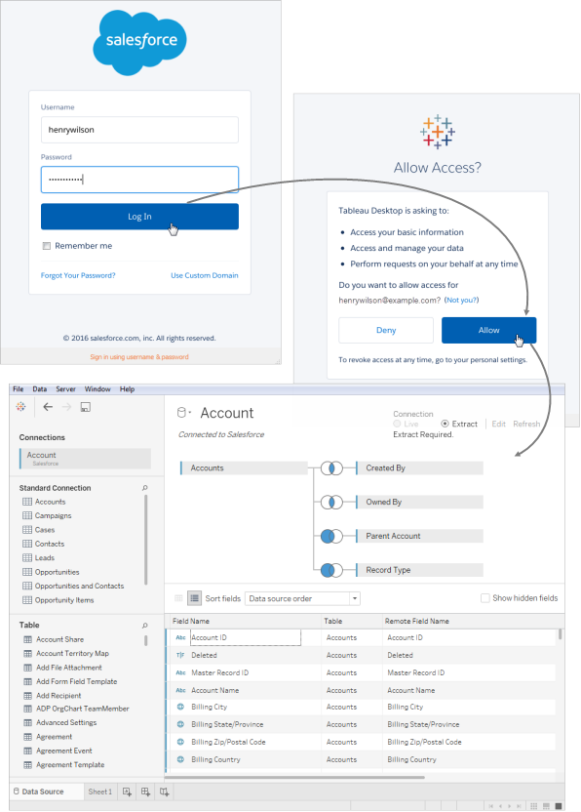

Use Dashboard Starters

If you are connecting to your data through Tableau Online, you can use a Dashboard Starter to quickly build informative dashboard designs made specifically for key business metrics. For more information, see Dashboard Starters for Cloud-based Data

Use joins in Salesforce

When you set up the data source on the data source page, when you drag a table to the canvas, the list of tables you can select from to join is filtered. You can create joins on any string fields and on fields that are constrained references between tables. (Only left and inner joins are supported.) You can also add joins later. For more information, see Join Your Data.

Cross-database join limitations with Salesforce

Salesforce also supports combining tables from different databases using a cross-database join. For more information, see the "Combine tables from different databases" section in Join Your Data.

When a Salesforce connection is included in a multi-connection data source, the data source won't support the following features:

* Live connections
* Extract filters
* Incremental updates to the extract
* Viewing your data in the data grid

Troubleshoot Salesforce connections

Tableau leverages the various force.com APIs to connect to Salesforce.com, Force.com, and Database.com data. These services have some restrictions on the type of data and the amount of data that you can access at a given time. If you are having trouble connecting, the following list of common restrictions may help you find a solution.

Company account and user profile configuration

In order for Tableau to connect to Salesforce data, all of the following must be enabled on both your company's account and your user profile:

* SOAP API for signing in
* REST API for getting meta data
* BULK API for downloading objects
* REST API for downloading objects that the BULK API does not support
* Replication SOAP APIs for retrieving changes in the data

In order to optimize for performance and ensure the APIs are available for all of their customers, Salesforce.com balances the load by limiting the number of concurrent API requests as well as limiting the total number of API requests overall. An error occurs if these limits are reached while connected using Tableau. See the Salesforce.com developer documentation to learn more about these limits.

**Note:** Some editions of Salesforce may not allow API access at all. Contact your Salesforce administrator to verify that your account has access to the above list of APIs.

Errors during extract

When you connect to Salesforce using Tableau, the data is automatically extracted into a Tableau Data Extract file. In some cases, certain fields cannot be extracted because of character limits. Specifically, text fields that are greater than 4096 characters and calculated fields will not be included in the extract. If you have calculated fields in your data, you will need to recreate them in Tableau after creating the extract.